Your personal Address:

Date of the day:

The Addresses to whom it may concern; personal doctors, insurance executives, and Federal Government Officials:

Dear Dr. Ms. Miss. Mrs.

Hello, I’ve been living with severe, debilitating, crippling chronic pain for ___ years. I am requesting the correct, honorable, safe, ancient, vetted, valued the 5 combined restorative therapies. The 5 include therapies for my mind, body, spirit, mental and most importantly muscle tissues. These therapies will release, nourish nurture and fuel my God given miraculous natural healing.

I have discovered that I must practice being my Personal Doctor and Health Care Advocate. I’m exercising my indelible, unalienable personal human rights to be treated humanely so that I may be free of miserable pain and pursuit of happiness.
- I’ve paid my health insurance premiums to cover all expenses

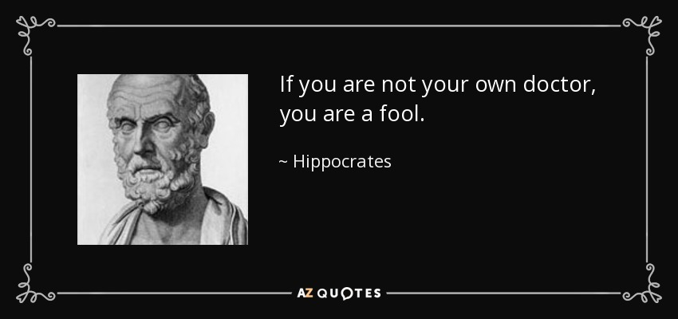

Here are a few of the Masters of Muscle Restoration:
Travell & Simons', C. Chan Gunn, Edward Rachlin, George Hackett, Ted Lennard, D. Vivian, Stevan Walkowski, Aneesh Singla, G. Burke, DiFabio and Pybus, P. Baldry, D. D. Palmer, C. Gokavi, D. Starlanyl, L. Chaitow, M. Seems, L. Rapson, and Joseph Helms.

Little did I know my Constitutional, Civil, Human, and Moral Rights have been denied and omitted by a complex sophisticated criminal minded individual within Health and Human Services. I have done some research and discovered the 1990 a federal judge determine the AMA had been involved lying, cheating, deceiving, racketeering for half century. Thanks to Dr. Chester Wilkes who brought on the case in 1976.

The antiscience, fraud, criminal, quack, unethical, and immoral scheme in a nutshell:
- arthritis wearing tearing degenerating our “delicate” musculoskeletal, joint tissues causes crippling miserable and disabling pain and inflammation visualized by x-ray and will only benefit from medications and operations.
- The weakest organ within the human within our body is the skeleton and joints which is so pathetically weak, orthopedic and neurosurgeons must amputate the bad parts with knives and bone saws repairing and replacing the worthless tissues with nice shiny new man-made bionic devices.
- Chiropractors are dangerous greedy quacks which must be eliminated off the face of the earth.
- Acupuncturists are dangerous greedy quacks which must also be eliminated off the face of the earth.
- The accepted standards of care are based on the skeleton and internal organs causing all pain and misery. This invention idea or belief is tragically wrong. Wrong can never be right. Doing wrong is wrongdoing and criminal felony assault and battery deadly weapons.
- The federal mandated and ordered standards of care contain deadly scientific errors and if used at the wrong time will kill instantly.

The right way is always the right way. The wrong way is always the wrong way.

The right way to help anyone is clear and simple 1-2-3:
People stricken with a disease or physical or mental trauma:
- FIRST offer personal services; The Miraculous Benefit.
- Consider medications as The Added Benefit.
- Surgery removal of deadly tissues. The Subtraction Benefit.

Facts: Natural Laws of Innate Healing of Diseases, Injury and Wound Repairing, and Ruined Cell Reprocessing:

- Our body works perfectly in our favor every second of our lives – with our daily care.
- Sleep deprivation is deadly, so our nutritional, exercise, charity and stretching.
- All 5 deprivations will cause one to feel so miserable suicide is constantly on their mind.
- The only way to benefit these 5 deprivations is with RX1.
- Drugs, surgeons, operations, chemicals, pills, opioids do not and cannot release natural healing they are solely beneficial as additions and subtractions.

The 3 way to help a person in need is always 1-2-3:
- The number 1 most deadly American affliction is a natural daily life full of stresses, strains, dramas, traumas, contusions, collisions, concussions, bereavement, loss, frictions, fractures, verbal and physical abuse deceit, and betrayal.
- The treatments for this deadly affliction include 30 parts, teams of helping hands and therapists. It is a recipe which can be easily customized to meet my personal needs and requirements. The recipe, protocol, or template I refer to as First Therapies as outlined below.
- The science behind RX1 is clear and simple. Our body design by miraculous heals perfectly from birth to death with our daily restorative requirements and chores.
- RX2-Drugs cannot heal their benefit is an addition.
  - Using drugs in the place of RX1 will not fully benefit people and are thus placebo. Using a placebo when the therapy is your fingertips is criminal and immoral.
- RX3-Surgery cannot heal. Removing infected necrotic corrupted tissues benefit is subtraction.
  - Using knives, scalpels, bone saws, chisels, drills, screws, plates, hardware store and auto-parts to treat pain is assault with deadly weapons potentially manslaughter.

The Muscular Organ System and the 5 Stages of Muscle Tissue Failure looks-like and Battle Fatigue:
- Regular: Stress and strains
- Over-Worked: Over-stressed, over-strained muscles leaving zillions of muscle tissue damages locked within millions of muscle fiber kinks and knots without blood flow.
- Moderate. The muscles are very dense, tight. Fresh blood is necessary to flush out the deadly wastes, toxins, poisons, and rotate, ruined muscle fibers/debris – my pain is a build up of crap all over my body.
- Severe: The muscles, tissues, and systems are suffocating, dying, decaying as the other organ systems become dysfunctional, malfunction, and “I feel weird” metabolic dysregulation experiences.
- Deadly: All these unnecessary electrical shocks impulses and perceptions bombard my CNS PNS leaving me a miserable zombie.
  - Pseudo-Cancer Concept: The Telomeres will fray and look like cancer cells, so in effect, due to Medical Doctor negligence my muscle tissues have degraded and are NOT functioning optimally.
  - I am dying of Muscle Tissues Movement Dysfunctions, Organ Functions and Systems Failure!

Mechanism of Actions via Gunn-Cannon's Law:
- Stretching, flexing, the range of motion as per age-old yoga, Tai-Chi, pre-game/post-game stretching, cool down.
- Massage-kneading per age-old elbow grease.
- Pulling and traction as per Chiropractic and Osteopathic techniques.
- Intramuscular Needling via an Acupuncture Needles as C. Chan Gunn, MD IntraMuscular Stimulation.
- Intramuscular Hypodermic Needling as per Travell-Simons aka Myofascial Trigger Point Injection Needling.

My 5-20 self-care daily part in a mnemonic Stephen S. Rodrigues, M.D.:
- SSRMD + LY + SPA + Yoga = Stop, Sleep, Retreat, Meditate, Decompress. Love-You. Stretch Pamper Awareness. And regular yoga. Diet, extra vitamins, and magnesium supplements, exercise, stretching, heating with pads or hot tubs, Epsom soaking, massage, chiropractic spinal adjustments, and most importantly, sleep hygiene.
  - 8-10 hours of sleep.
  - Self-yoga.
  - Naps. :)
  - Epsom salt bath, soaking, and dunking.
  - 1-hour of mindfulness to refresh and clear up the mind and soul.
  - 1-hour of exercise to build muscles.
  - 1-hour of stretching to rebuild muscles.
  - Grace, love, and forgiveness are working on whittling down my ego and pride.

My Treatments consist of 6 therapeutic members in my personalized team of helpers:
- Mental, emotional, and psychological to help my deep brain recover.
- Life coaches, social workers, and case managers to help with the degradation of my life, finances, and loss of will and purpose.
- Mindfulness and spiritual healing therapist.
- Hands-on therapist such as massage, spray and stretch, manual labor myofascial release.
- Masterful hands-on therapists such as chiropractors, osteopaths, and myofascial release professionals.
- Doctors who have Mastered Muscle Tissue Release Rebuilding Recovery disciplines such as acupuncture, dry needling, Gunn IMS, and all the variations of Travell-Simons.

Notes:
- I will require as many sessions as needed until I’m feeling better, ready to return to full-duty work and play so I can pursue happiness.
- These numbers, frequencies, helpers, options, tools, and amount of care and services maybe 10, 100, or more depending on the density of my unique disease:
  - 9 a.m. One-hour massage, myofascial release, and the like.
  - 10 a.m. Chiropractic and osteopathic manipulations.
  - 10:30 a.m. Acupuncture and needling.
  - 11:30 a.m.: Chiropractic - AGAIN - spinal unwinding.
  - 12:00 p.m. Self-yoga. 12:30 p.m. Nap.
  - Repeat 2-5x per week until 50% of normal.
  - Repeat weekly until 75% of normal.
  - Repeat monthly until 90% of normal.
  - On call at every 4-6 months to maintain fitness for full-duty and play in the pursuit of happiness.

When will I receive my written and formal response so then I can begin my therapies, healing, and recovery?

Respectfully,

Your name and signature

Updated 11/05/2018

